EXPERIMENTS

NAME:BHARANI DHARAN S
REG NO:192424141
COURSE CODE:DSA0602 DATA HANDLING AND VISUALIZATION

SET 8 – EMPLOYEE PERFORMANCE ANALYSIS

Employee ID | Department | Years of Service | Performance Score
1 | Sales | 5 | 85
2 | HR | 3 | 92
3 | Marketing | 7 | 78

QUESTION 1
Create a line chart to visualize the performance trend of employees over time. Label the axes and title the chart.

AIM
To create a line chart showing the performance trend of employees based on their years of service.

PROCEDURE
- Create the employee performance dataset.
- Store Employee ID, Department, Years of Service and Performance Score.
- Use plot() to create a line chart.
- Use Years of Service on the X-axis.
- Use Performance Score on the Y-axis.
- Add axis labels and a suitable title.

CODE

employee <- data.frame(
Employee_ID = c(1, 2, 3),
Department = c("Sales", "HR", "Marketing"),
Years_of_Service = c(5, 3, 7),
Performance_Score = c(85, 92, 78)
)

employee <- employee[order(employee$Years_of_Service), ]

plot(
employee$Years_of_Service,
employee$Performance_Score,
type = "o",
xlab = "Years of Service",
ylab = "Performance Score",
main = "Employee Performance Trend"
)
OUTPUT

RESULT
Thus, the line chart representing the employee performance trend was successfully created.

QUESTION 2
Generate a bar chart showing the distribution of employees across different departments. Label the chart elements.

AIM
To create a bar chart showing the number of employees in each department.

PROCEDURE
- Create the employee performance dataset.
- Count the employees in each department.
- Use the table() function.
- Use the barplot() function.
- Add suitable axis labels and a title.

CODE
employee <- data.frame(
Employee_ID = c(1, 2, 3),
Department = c("Sales", "HR", "Marketing"),
Years_of_Service = c(5, 3, 7),
Performance_Score = c(85, 92, 78)
)

department_count <- table(employee$Department)

barplot(
department_count,
xlab = "Department",
ylab = "Number of Employees",
main = "Employee Distribution by Department"
)
OUTPUT

RESULT
Thus, the bar chart showing the distribution of employees across departments was successfully created.

QUESTION 3
Build a table to display the performance data for each employee. Label the table elements.

AIM
To create and display a table containing the performance information of each employee.

PROCEDURE
- Create the employee performance dataset.
- Enter Employee ID, Department, Years of Service and Performance Score.
- Assign suitable column names.
- Display the data using print().

CODE
employee <- data.frame(
Employee_ID = c(1, 2, 3),
Department = c("Sales", "HR", "Marketing"),
Years_of_Service = c(5, 3, 7),
Performance_Score = c(85, 92, 78)
)

print(employee)

OUTPUT

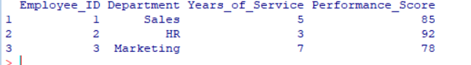

RESULT
Thus, the employee performance data was successfully displayed in a labelled table.

QUESTION 4

Develop a Tableau dashboard combining the line chart, bar chart, and the table for interactive exploration of employee performance data.

AIM
To develop an interactive employee performance dashboard using R Shiny by combining a line chart, bar chart and performance table.

PROCEDURE
- Create the employee performance dataset.
- Load the Shiny package.
- Create the dashboard user interface.
- Create the line chart for performance trend.
- Create the bar chart for department distribution.
- Create the employee performance table.
- Add a department filter.
- Run the Shiny application.
- View the interactive dashboard in the browser.

CODE
library(shiny)

employee <- data.frame(
Employee_ID = c(1, 2, 3),
Department = c("Sales", "HR", "Marketing"),
Years_of_Service = c(5, 3, 7),
Performance_Score = c(85, 92, 78)
)

ui <- fluidPage(
titlePanel("Employee Performance Dashboard"),

sidebarLayout(
sidebarPanel(
selectInput(
"department",
"Select Department:",
choices = c("All", unique(employee$Department))
)
),

mainPanel(
plotOutput("linePlot"),
plotOutput("barPlot"),
tableOutput("employeeTable")
)
)
)

server <- function(input, output) {

filteredData <- reactive({
if (input$department == "All") {
employee
} else {
employee[employee$Department == input$department, ]
}
})

output$linePlot <- renderPlot({
data <- filteredData()
data <- data[order(data$Years_of_Service), ]

plot(
data$Years_of_Service,
data$Performance_Score,
type = "o",
xlab = "Years of Service",
ylab = "Performance Score",
main = "Employee Performance Trend"
)
})

output$barPlot <- renderPlot({
data <- filteredData()

department_count <- table(data$Department)

barplot(
department_count,
xlab = "Department",
ylab = "Number of Employees",
main = "Employee Distribution by Department"
)
})

output$employeeTable <- renderTable({
filteredData()
})
}

shinyApp(ui = ui, server = server)

OUTPUT
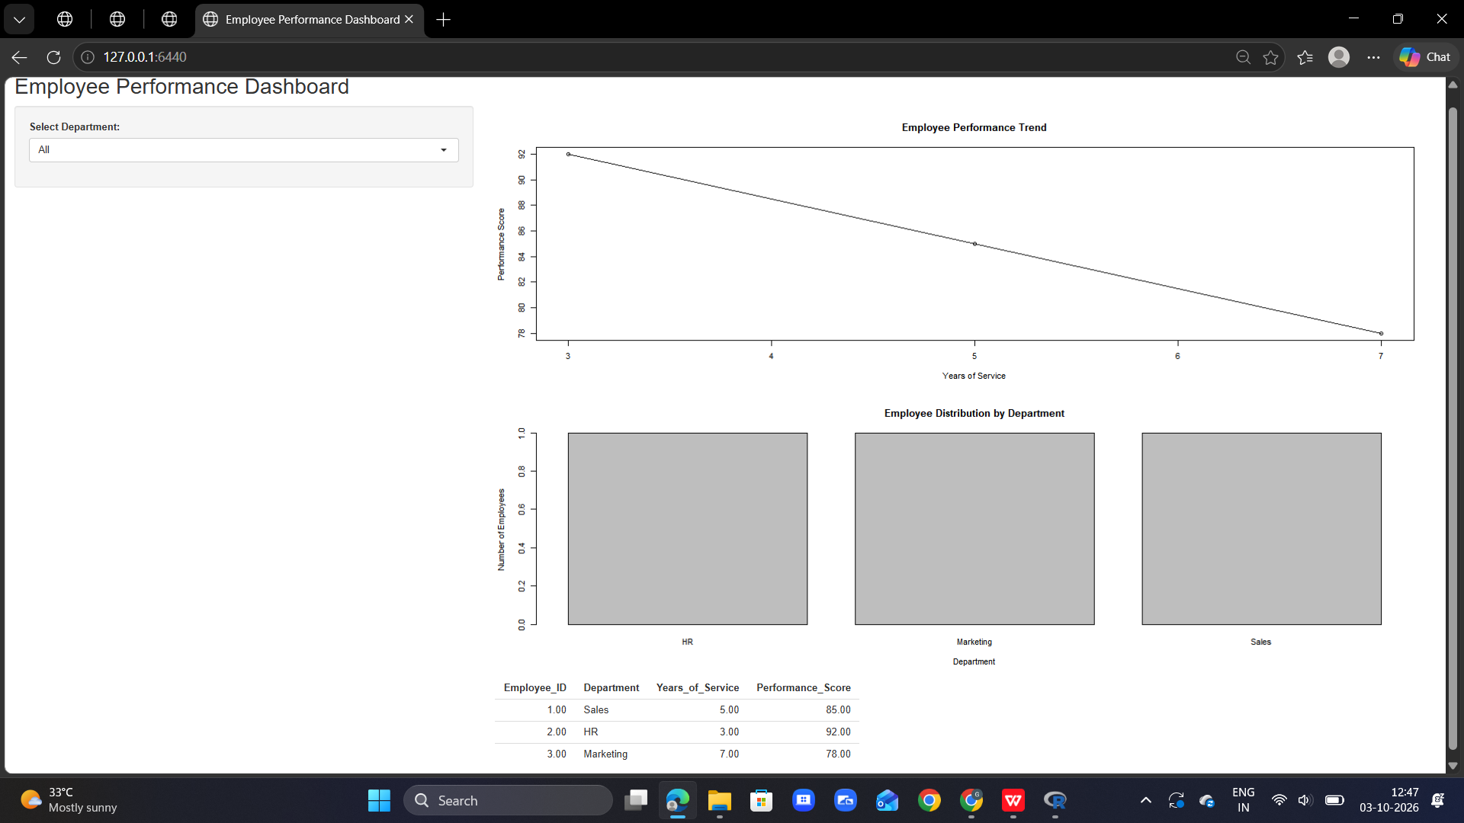

RESULT
Thus, an interactive employee performance dashboard containing the line chart, bar chart and employee performance table was successfully created using R Shiny..

